UCS503 Software Engineering Lab

COVISAFE

UCS503- Software Engineering Project Report

Mid-Semester Evaluation

Submitted by:
(102017182) SANDHYA GOYAL (Offline)
(102197024) STUTI WADHWA (Offline)
(102197020) AHMED KAMRUDDIN (Offline)
(102197018) GAURAV GUPTA (Offline)

BE Third Year, COPC

Group No: 2

Submitted to: Ms. Ashima



Computer Science and Engineering Department

TIET, Patiala

March 2022
Table of Contents
1. Project Selection Phase iii
1.1 Software Bid iii
2. Planning Phase viii
2.1 Project Write Up viii
3. Analysis Phase ix
3.1 Use Case Template ix
3.2 Use Case Diagram xii
3.3 Activity Diagram xiii
3.4 Swimlane Diagram xiv
3.5 Data Flow Diagrams xv
3.5.1 Level 0 xv
3.5.2 Level 1 xvi
3.6 Software Requirement Specifications (SRS) in IEEE Format xvii
3.7 Data Dictionary xvii
3.7.1 Data Store xvii

1. Project Selection Phase

1.1 Software Bid

Software Bid/ Project Teams
UCS 503 - Software Engineering Lab

Group : 2CS8 Dated: 27/01/2022

Team Name: Bugs & Bots
Team ID (will be assigned by Instructor): 2

Please enter the names of your Preferred Team Members.

• You are required to form a three to four person teams
• Choose your team members wisely. You will not be allowed to change teams.

Name | Roll No | Project Experience | Programming Language used
Gaurav Gupta | 102197018 | Weather Forecasting App using API, Fire Emergency Alarm using Arduino,  Automated Hand Sanitizer Dispenser,  Library Management System. | C, C++, Java
Stuti Wadhwa | 102197024 | Designed a working mangonel project with coding on Arduino to determine projectile range | C, C++
Ahmed Kamruddin | 102197020 | Temperature controlled fan using Arduino, Projectile Configuration using Arduino | C, C++
Sandhya Goyal | 102017182 | Covid Room with social Distancing and Alarm systems, Webpage designing | C, C++

Programming Language / Environment Experience
List the languages you are most comfortable developing in, as a team, in your order of preference. Many of the projects involve Java or C/C++ programming.
1.C++
2.C
3.Java

Choices of Projects:
Please select 4 projects your team would like to work on, by order of preference: [Write at-least one paragraph for each choice (motivation, reason for choice, feasibility analysis, etc.)]

First Choice | COVISAFE:  As much as covid affected our college life, a software that helps to track positive as well as exposed people and caters to the needs of those in isolation is of prime importance.  This software aims at maintaining a database of all the positive students on campus, their contact tracing, several lists of isolated and quarantined students spanning all the hostels and would also cater to the needs and necessities of the positive students. It would also have a health advisory portal, enabling students to contact medical workers in case of any emergency at any time of the day. This would be further strengthened by a notification system that timely informs the respective caretakers, wardens and guardians of the health condition of students. Students would be able to avail ambulance facility through the app in case of any exigency. This software would not only track positive patients and cater to their needs, but would also help prevent the spread of covid, which is the need of the hour today. Also, a student’s medical record would be readily available to the medical staff.  During the dormancy of covid, the features of this app would still remain relevant as the required officials and health workers would be notified if any student falls sick on campus. Students could avail delivery services from COS, G-block and other shops in the campus.
Second Choice | HOSTEL ALLOTMENT:  Students are required to enter their credentials, hostel preference and room type. Selection of room would be similar to the interface of airplane seat booking.  Students could also include other details such as floor no., roommate and also if they would like to book rooms next to one another. This would ensure that each student gets an opportunity to stay with his or her friends. The allotment procedure would entirely be online as the document verifications would be digitally managed and controlled.  In addition, Thapar would have its own portal for hostel allotment and would no longer have to rely on google forms
Third Choice | THAPAR FOOD DELIVERY SYSTEM:  A centralized software for easy, contact-free and efficient food delivery across the Thapar campus, be it a tiring day, a sudden craving for a cheat meal or a party with friends, this delivery system takes care of all your dining needs. In times of pandemics like covid, it becomes necessary to ensure contact-free food delivery. The proposed software will have a rating system, a dedicated food blog for the aspiring bloggers of tomorrow .Services would include dine-in , pick-up and delivery.
Fourth Choice | MESS MANAGEMENT:  Students would be able to vote monthly for items they want in the menu of their respective hostels. This would also serve as an app through which feedback on the meal is provided. Students could also add/replace items they feel like should be on the menu by voting on it.  In case a student is unwell, he/she may request for special food to be made which would avoid having to stay in mess longer than needed.

Additional Remarks/ Inputs
Please tell us about any other factors that we should take into consideration (e.g., if you really would like to work on a project for some particularly convincing reason).

In recent times, people witnessed their personal and professional lives crippled by the pandemic.
Similarly, COVID-19 has affected our lives as well. The motivation behind this project of ours
(COVISAFE) is to help the students and administration in the campus to cope up with the situation.
The project aims at providing effective solutions to some of these problems faced and to ensure
safety in times of community transmission.

2. Planning Phase

2.1 Project Write Up
‘COVISAFE’ is a software that helps to track positive as well as exposed people and caters to the needs of those in isolation is of prime importance.
This software aims at maintaining a database of all the positive students on campus, their contact tracing, several lists of isolated and quarantined students spanning all the hostels and would also cater to the needs and necessities of the positive students. It would also have a health advisory portal, enabling students to contact medical workers in case of any emergency at any time of the day. This would be further strengthened by a notification system that timely informs the respective caretakers, wardens and guardians of the health condition of students. Students would be able to avail ambulance facility through the app in case of any exigency. This software would not only track positive patients and cater to their needs, but would also help prevent the spread of covid, which is the need of the hour today. Also, a student’s medical record would be readily available to the medical staff.

During the dormancy of covid, the features of this app would still remain relevant as the required officials and health workers would be notified if any student falls sick on campus. Students could avail delivery services from COS, G-block and other shops in the campus.
Both the students and authorities can login through their credentials and can get access to the services provided.

3. Analysis Phase

3.1 Use Case Template

Use Case Identification and History
Use Case ID | UC1.1
Use Case | Login, Enquiry and Database Access
Description | The user can register or log in to their account to access Covisafe portal and enquire about Covid positive students.
End Objective | Access Covisafe portal
Primary Actors | Student
Secondary Actors | Hostel Authorities
Trigger | Open Covisafe
Frequency of Use | Frequent

Precondition
User is a student of Thapar.

Basic Flow
Step | User Actions | System Actions
1. | I want to register. | System generates a password and emails it to the user.
2. | I want to access Covisafe portal. | Verify credentials
3. | I want to know of Covid positive students in campus. | Fetch details of Covid positive students from hostel authorities and display.

Alternate Flow
Step | User Actions | System Actions
3. | I want to know of Covid positive students in campus. | Displays that campus is Covid free.

Exception Flow
Step | User Actions | System Actions
1. | I want to register. | Returns error as the user has already registered.
2. | I want to access Covisafe portal. | Returns error as invalid credentials have been entered.

Postcondition
System registers or logs in the user into their account.

3.2 Use Case Diagram

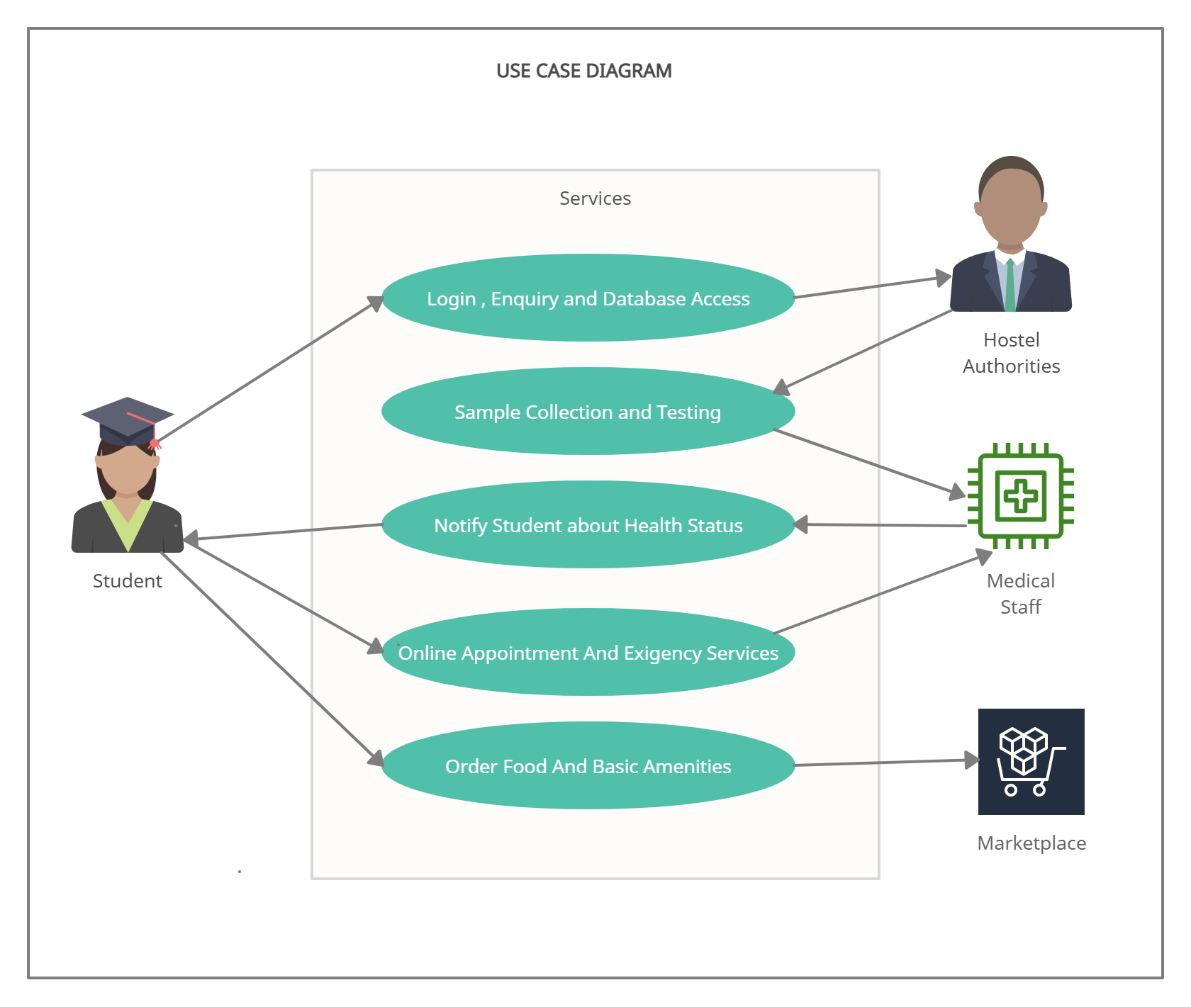

3.3 Activity Diagram

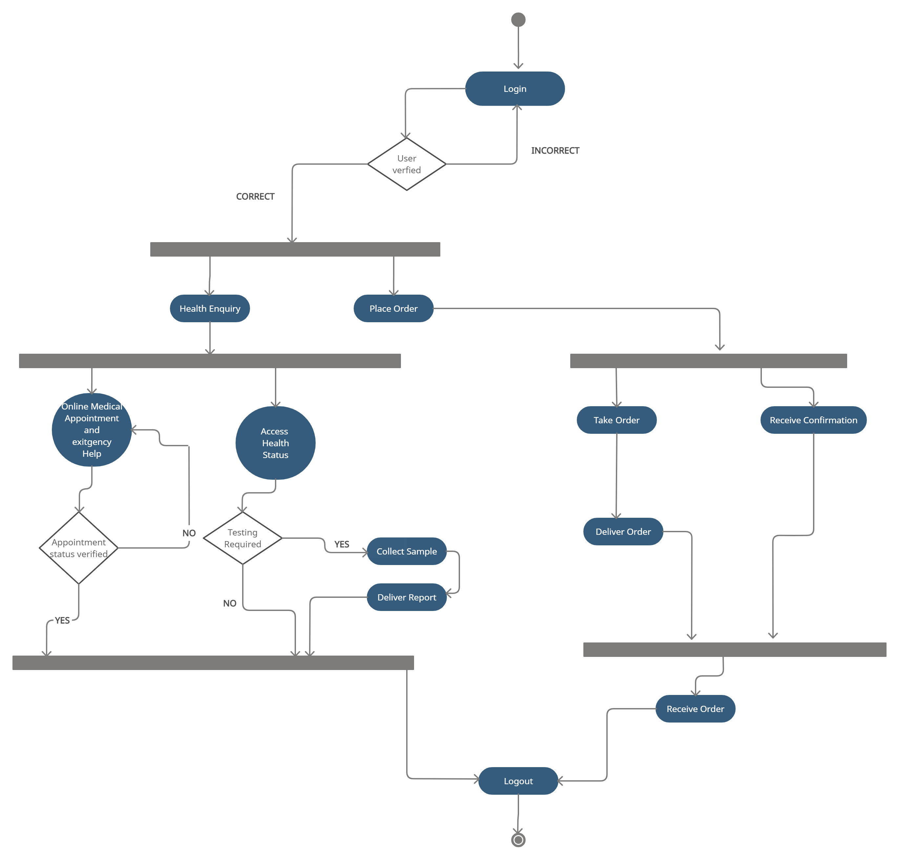

3.4 Swimlane Diagram

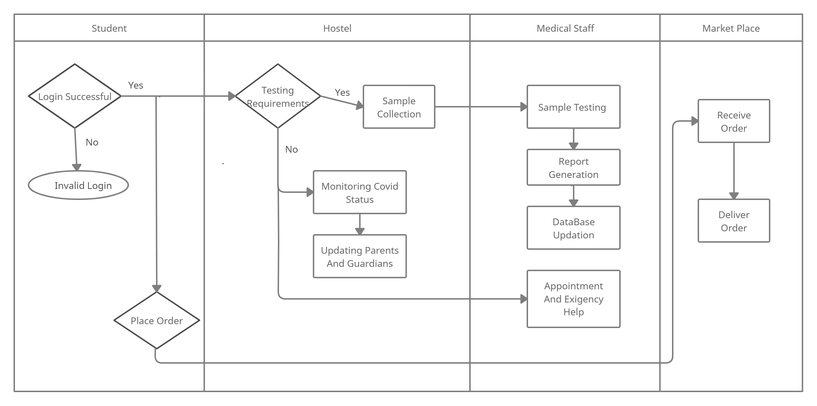

3.5 Data Flow Diagrams

3.5.1 Level 0

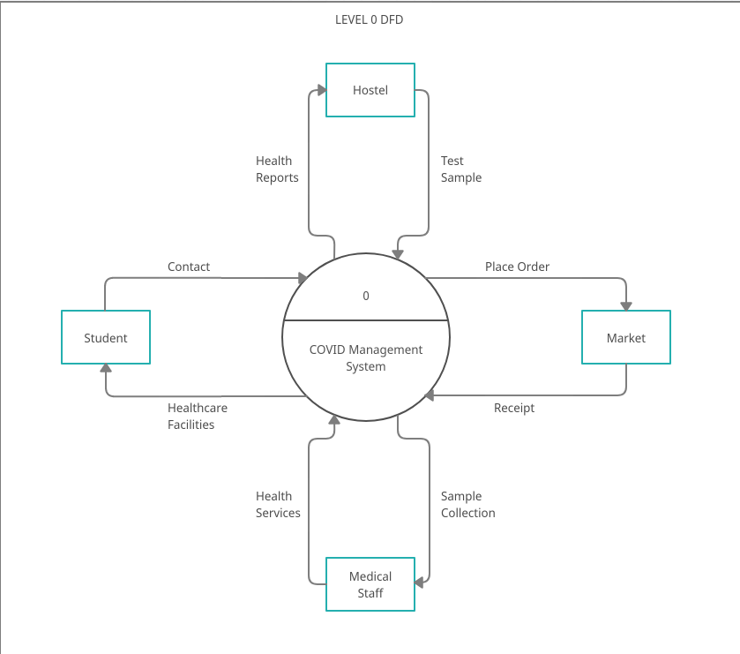

3.5.2 Level 1

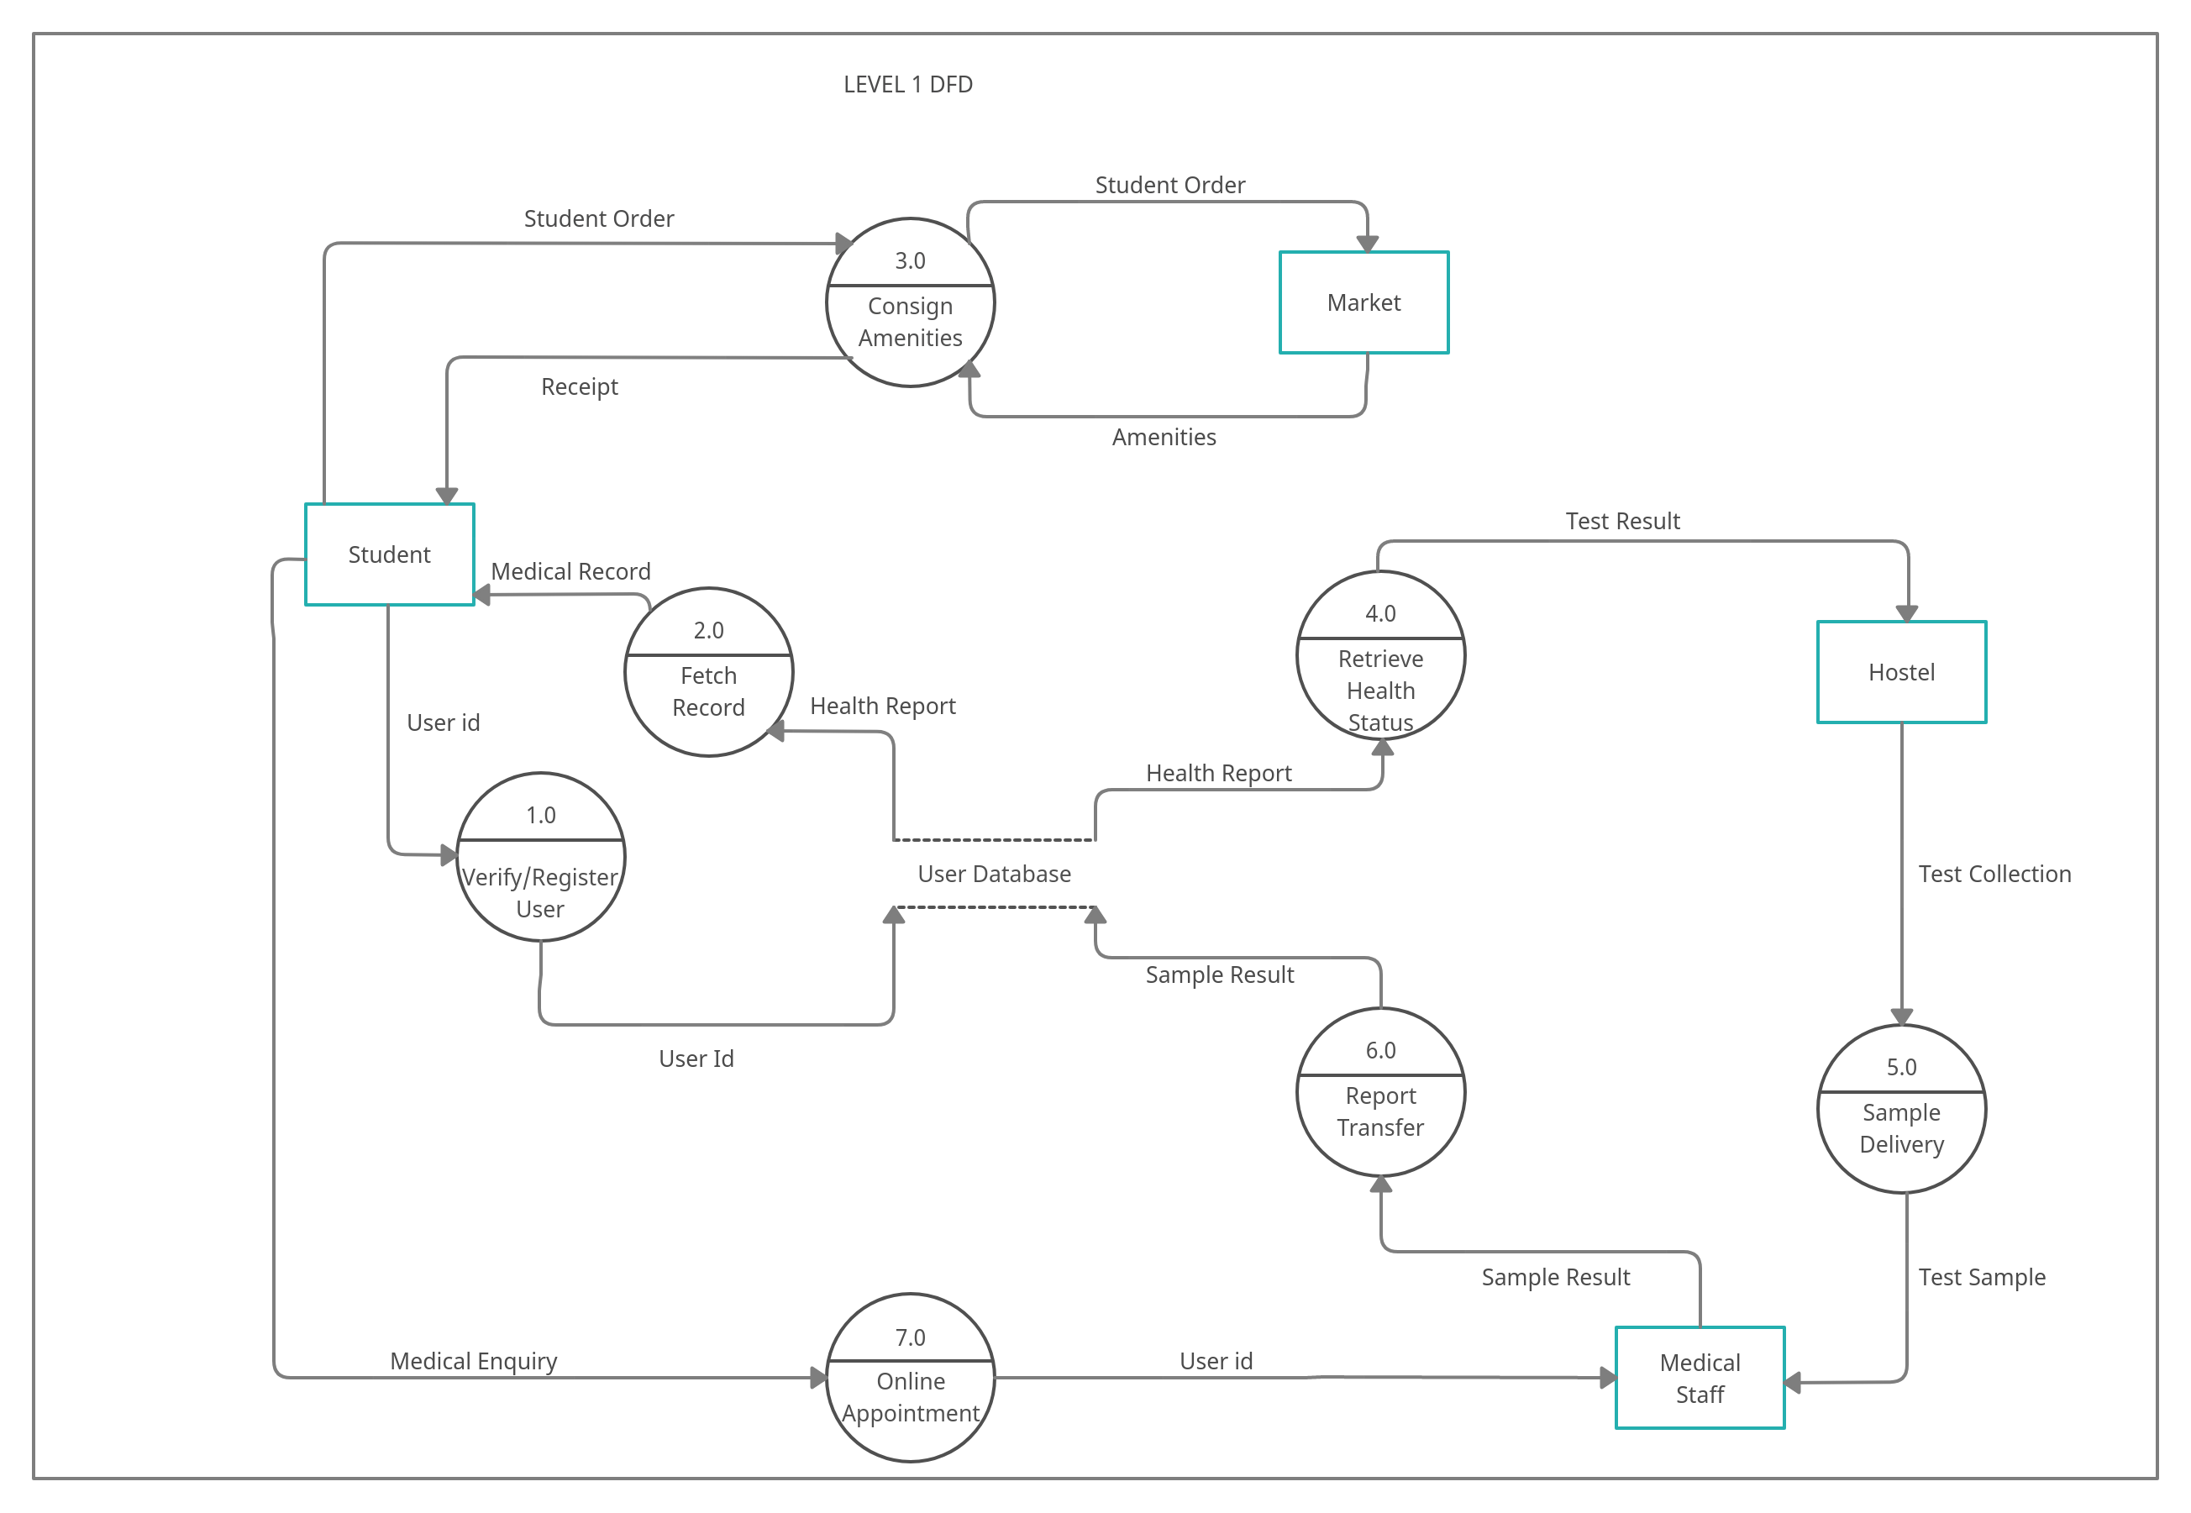

3.6 Software Requirement Specifications (SRS) in IEEE Format
SRS Document

3.7 Data Dictionary

3.7.1 Data Store
FIELDS | DATATYPE | SIZE | CONSTRAINTS | EXAMPLE | DESCRIPTION
Name | Characters | 30 | Not null | Candy | Name of the student
Roll_No | Number | 10 | Primary key | 1029821 | Roll no of the student provided by the university
Hostel | Characters | 10 | Not Null | N | Hostel allocated to the student
Room_ No | Number | 10 | Not Null | 567 | Room no in which he is currently residing
Contact No | Number | 15 | - | 9873404532 | Phone number of the student
Email | Characters | 20 |  | Candygoyal@gmail.com | Email id of the students provided by the college
Father_Name | Characters | 30 | - | Peterson | Father name of the student
Father_Contact | Number | 15 | - | 908765434 | Phone number of the student
Address | Characters | - | - | Model town,House no 10,Patiala,Punjab | Address of the student
Health Status | Characters | - | - | Well | Health condition about the student
Sample collect | Charaters | 10 | - | Yes/no | Whether or not the covid sample has been collected

